

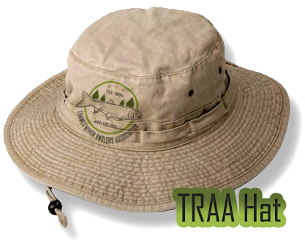

This stylish hat will serve any good angler out there with style and utility as it is not only devastatingly fashionable but also protects the wearer’s head from the sun remarkably well- whether they be fishing or doing volunteer work to help out the river. A must for any TRAA member.

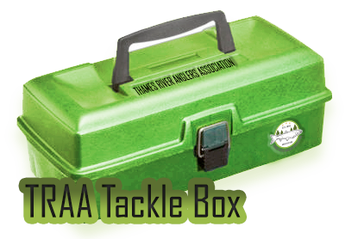

This green TRAA tackle box is required for any Thames River based fisherman, with lots of storage space, a snappy colour and embossed decals of the TRAA name on the lid and logo on the body. How can you say no to this stylish carrying case that will protect all your fishing gear for years to come?

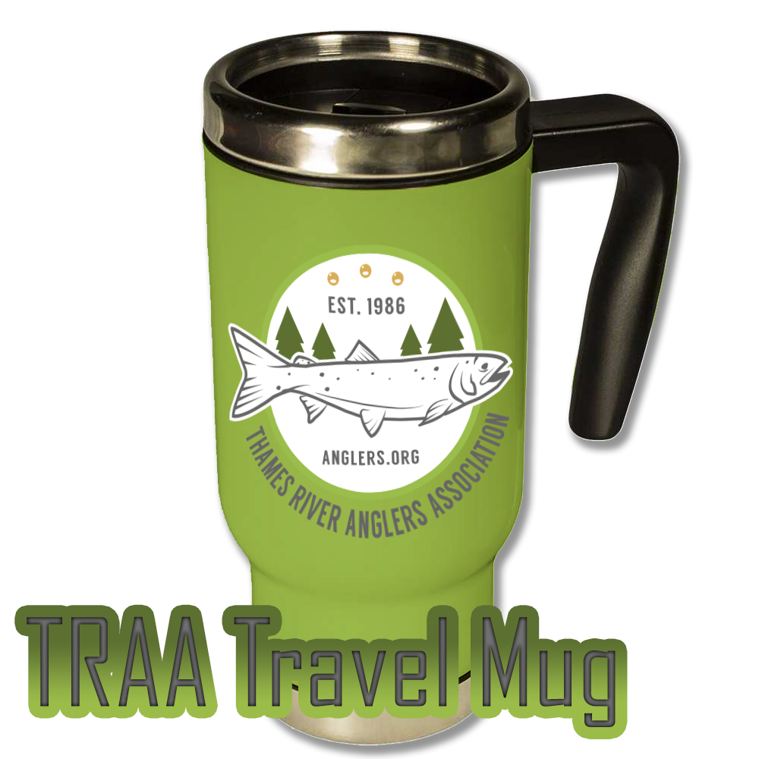

Whether doing their everyday errands, going out in the morning for an early fishing trip or just relaxing at home, this sturdy and travel mug will keep all your hot beverages piping hot until you’ve caught the big one for the day. In a fashionable green with the iconic logo, what else could you want?